**REPORT**

|  |
| --- |
| **Experiment 1: RC Circuit** |

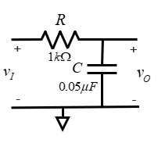

1.

|  |  |  |  |
| --- | --- | --- | --- |
| Frequency (Hz) | 5K | 10K | 15K |
| Vout,pp(V) | 5.12 | 2.88 | 2.08 |

**ADJUST THE OSCILLOSCOPE APPROPRIATELY**

5k Hz Vin and Vout waveform

(1pic)

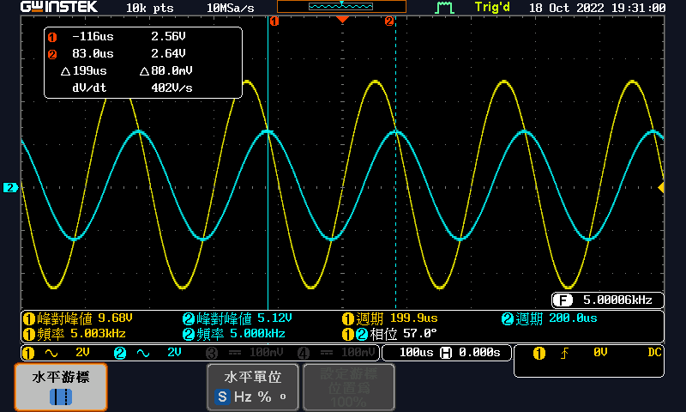

10k Hz Vin and Vout waveform

(1pic)

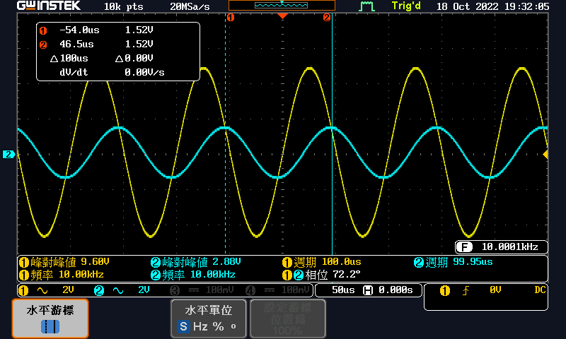

15k Hz Vin and Vout waveform

(1pic)

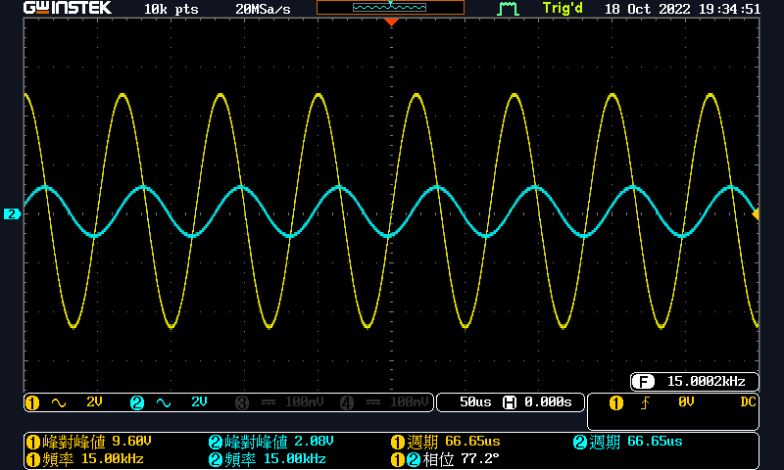

2.

Vin and Vout waveform

(1pic)

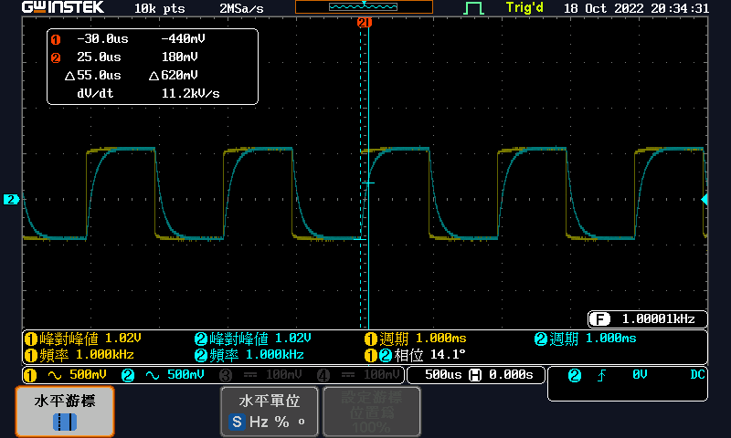

time constant =Δt = Δx = 500u second (i.e. the value you use “cursor” function to measure )

Question for Exp1:

1. Vo(jw)/Vi(jw) = ?
$$\frac{V_{o}}{V_{i}}=\frac{\frac{1}{jω⋅ 0.05⋅{10}^{-6}}}{1⋅{10}^{3}+\frac{1}{jω⋅ 0.05⋅{10}^{-6}}}=\frac{1}{{10}^{3}⋅jω⋅0.05⋅{10}^{-6}+1}=\frac{1}{5⋅{10}^{-5}jω+1}$$

2. Draw the Bode plot of the circuit and mark the frequency of the input signal with the three different frequency. (1 rad/s=1/(2π) Hz)

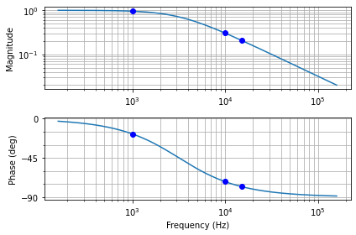

1. Describe the describe the difference of three points. What are the magnitudes of the Bode plot at these three different frequecies? What is the trend of magnitude? What kind of filter is it

f=1000: 0.9540287978953218

f=10000: 0.3033754610171704

f=15000: 0.2075945372352011

It is getting smaller and smaller. Therefore, the circuit is a low pass filter.

|  |
| --- |
| **Experiment 2: RL Circuit** |

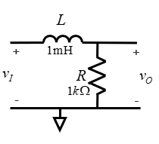

1.

|  |  |  |  |
| --- | --- | --- | --- |
| Frequency (Hz) | 100K | 200K | 300K |
| Vout,pp(V) | 4.72 | 7.52 | 9.40 |

**ADJUST THE OSCILLOSCOPE APPROPRIATELY**

100k Hz Vin and Vout waveform

(1pic)

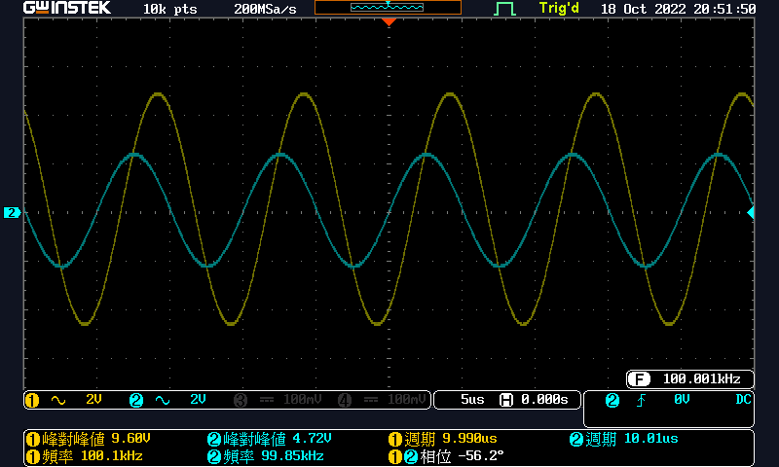

200k Hz Vin and Vout waveform

(1pic)

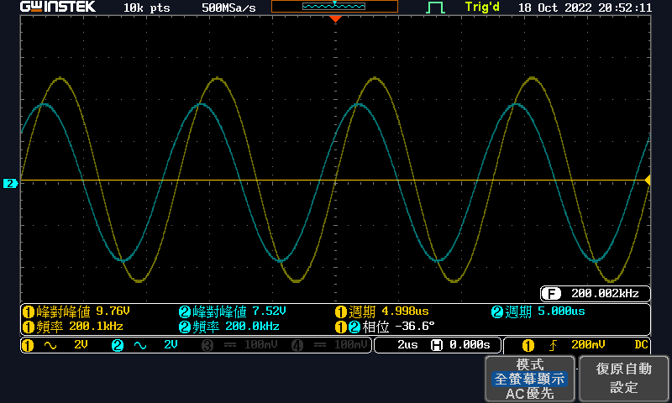

300k Hz Vin and Vout waveform

(1pic)

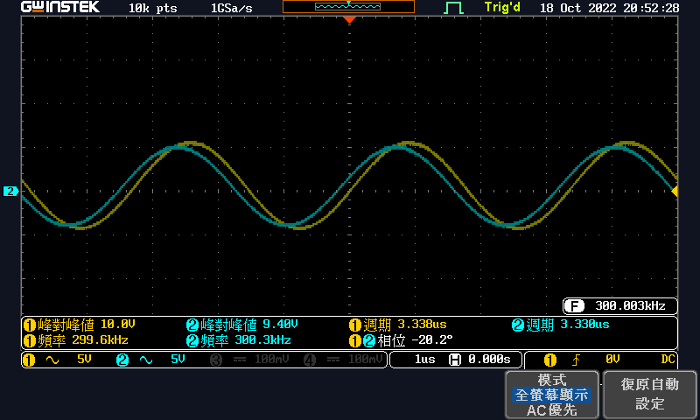

2.

Vin and Vout waveform

(1pic)

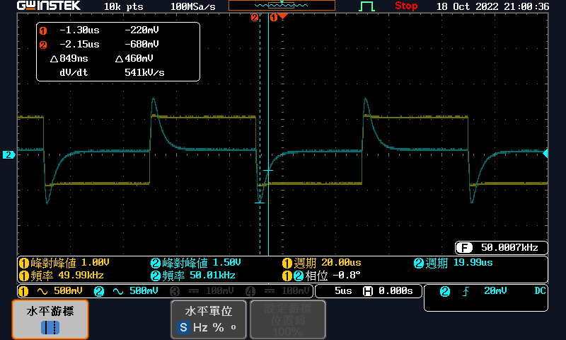

time constant =Δt = Δx = 849n second (i.e. the value you use “cursor” function to measure )

Question for Exp2:

1. Vo(jw)/Vi(jw) = ?
$$\frac{V_{o}}{V_{i}}=\frac{jω⋅ {10}^{-3}}{1000+jω⋅{10}^{-3}}$$

2. Draw the Bode plot of the circuit and mark the frequency of the input signal with the three different frequency. (1 rad/s=1/(2π) Hz)

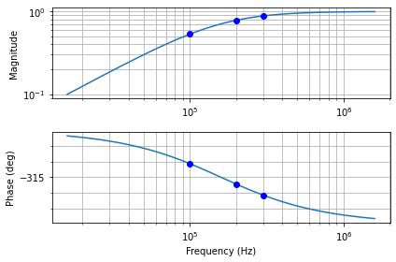

1. Describe the describe the difference of three points. What are the magnitudes of the Bode plot at these three different frequecies? What is the trend of magnitude? What kind of filter is it

f=100k 0.5319965837015993

f=200k 0.7824439352687451

f=300k 0.8833721067251833

The magnitude of the three different frequencies are increasing. Therefore, the circuit is a high pass filter.

|  |
| --- |
| **Experiment 3: Speaker properties and signal sound** |

**ADJUST THE OSCILLOSCOPE APPROPRIATELY**

1.

waveform for FG + OSC

(1pic)

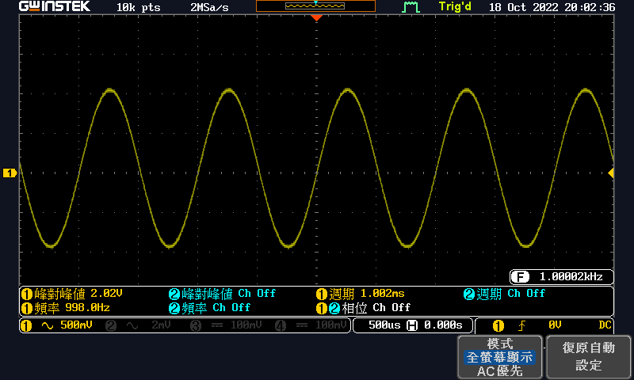

2.

waveform for FG + OSC + Speaker

(1pic)

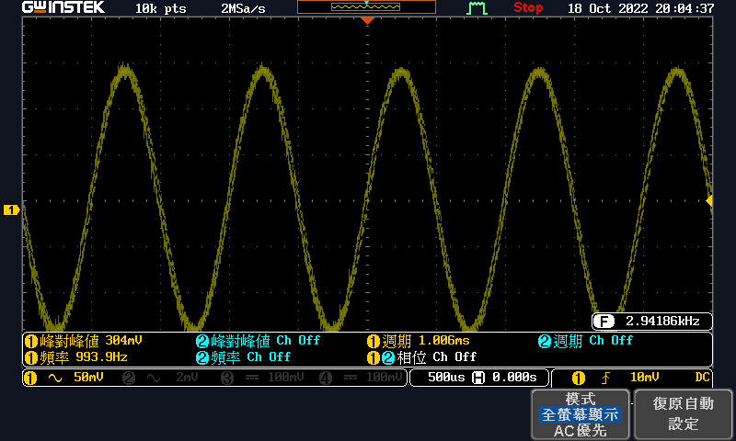

|  |  |
| --- | --- |
| **Configuration** | **Vpp of OSC CH1 (V)** |
| FG + OSC | 2.02V |
| FG + OSC + Speaker | 304mV |

Question:

Are there any differences between these two connections?

The $V_{pp}$ of the second configuration is very small.

Can you explain the phenomena? Hint: voltage divider

Because the internal resistance of the speaker is very high, the voltage measured on the resistor will be very small.

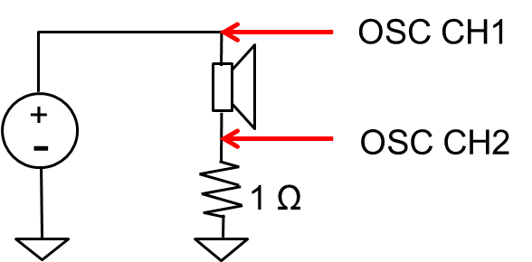

3.

①

CH 1 leads CH 2 by 7.32 degree.

CH1 and CH2 waveform (1 KHz)

(1pic)

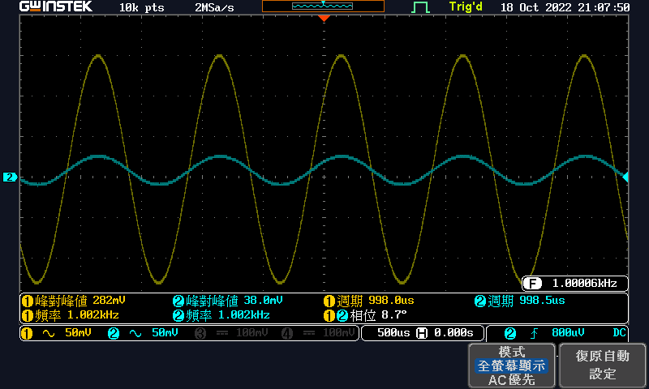

X-Y mode plot(1KHz)

(1pic)

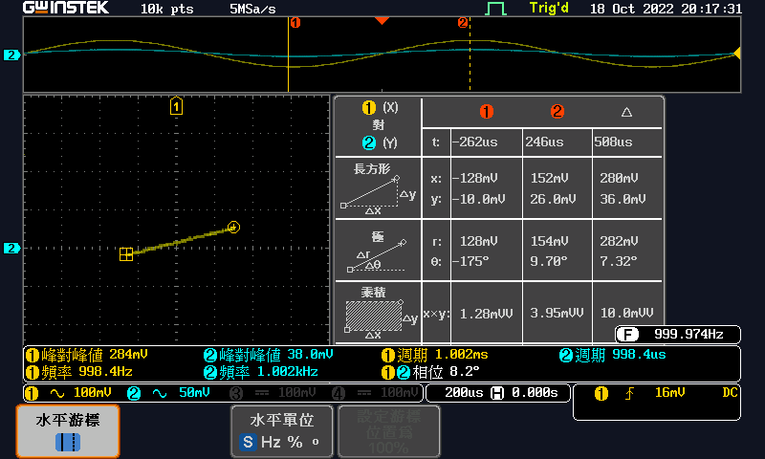

②

CH 1 leads CH 2 by 6.65 degree.

CH1 and CH2 waveform ( 10 KHz)

(1pic)

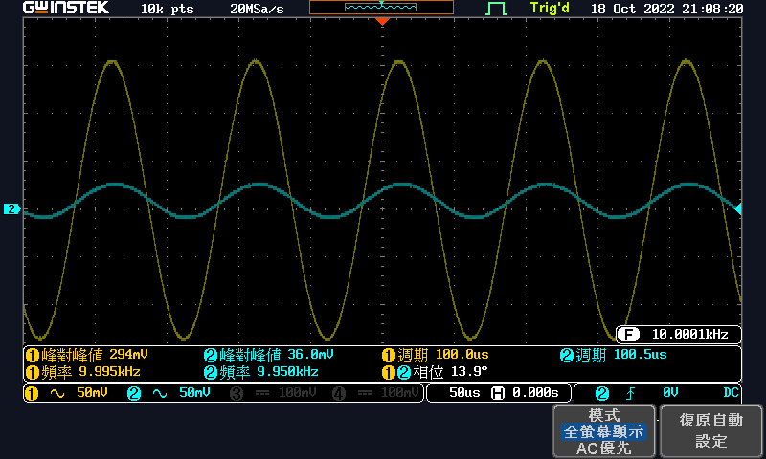

X-Y mode plot (10 KHz)

(1pic)

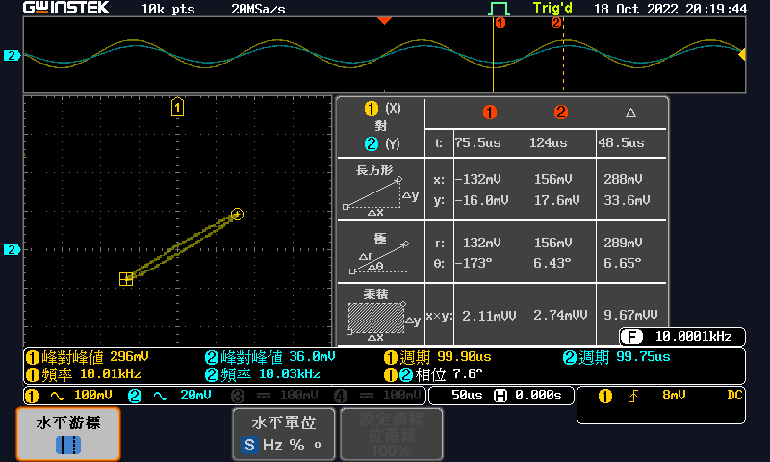

Question:

Use the following configurations to simulate Exp3-3① and Exp3-3②

|  |  |  |  |
| --- | --- | --- | --- |
| Circuit Model | Inductor Attribute | Shape | Frequency (Hz) |
|  |  | sine | 1k |
| 10k |

Please attach your LTSPICE simulation result for this experiment. (Both waveform and schematic)

Exp3-3①

waveform

(1pic)

schematic

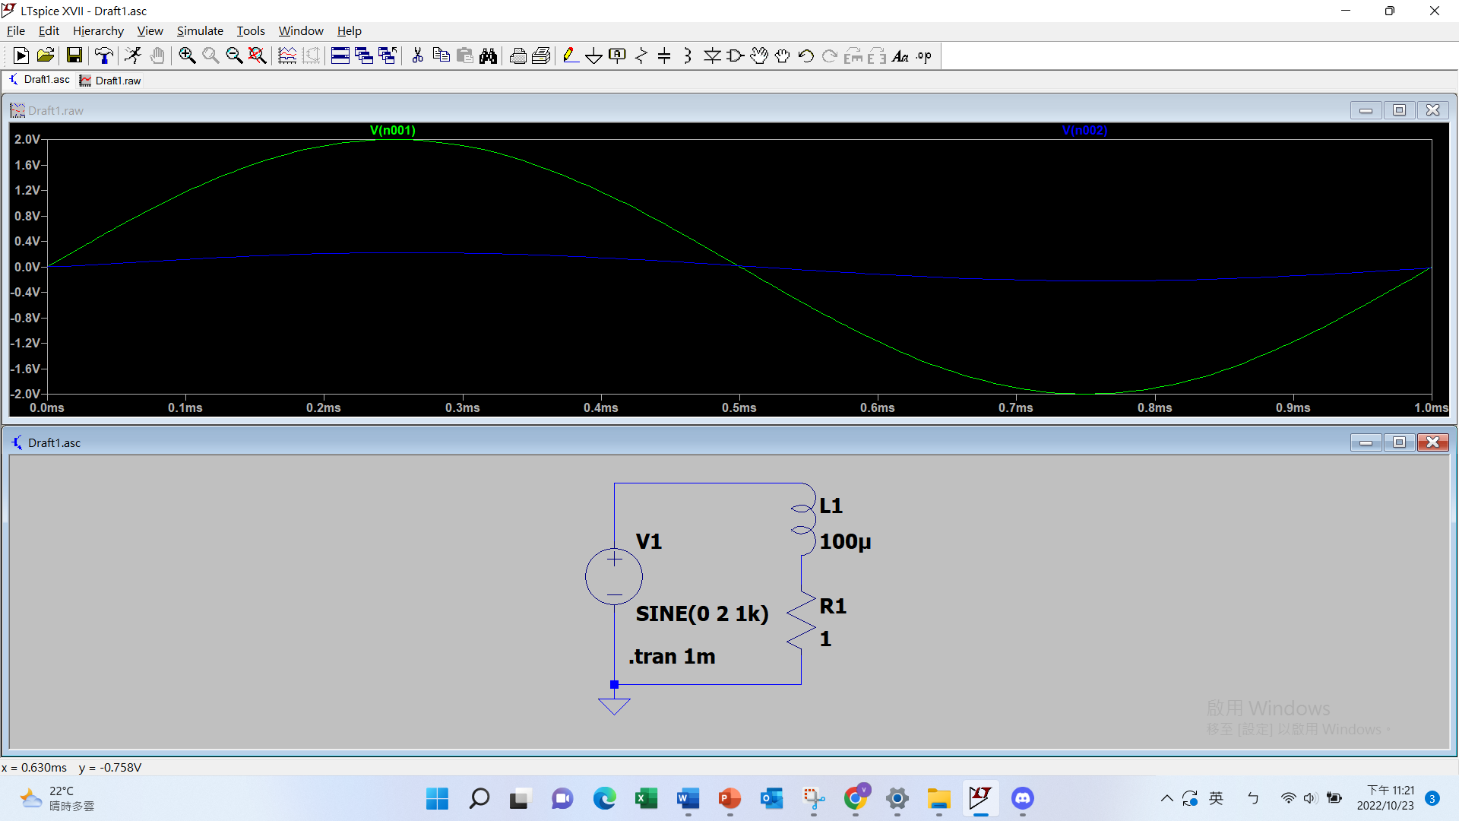

Exp3-3②

waveform

(1pic)

schematic

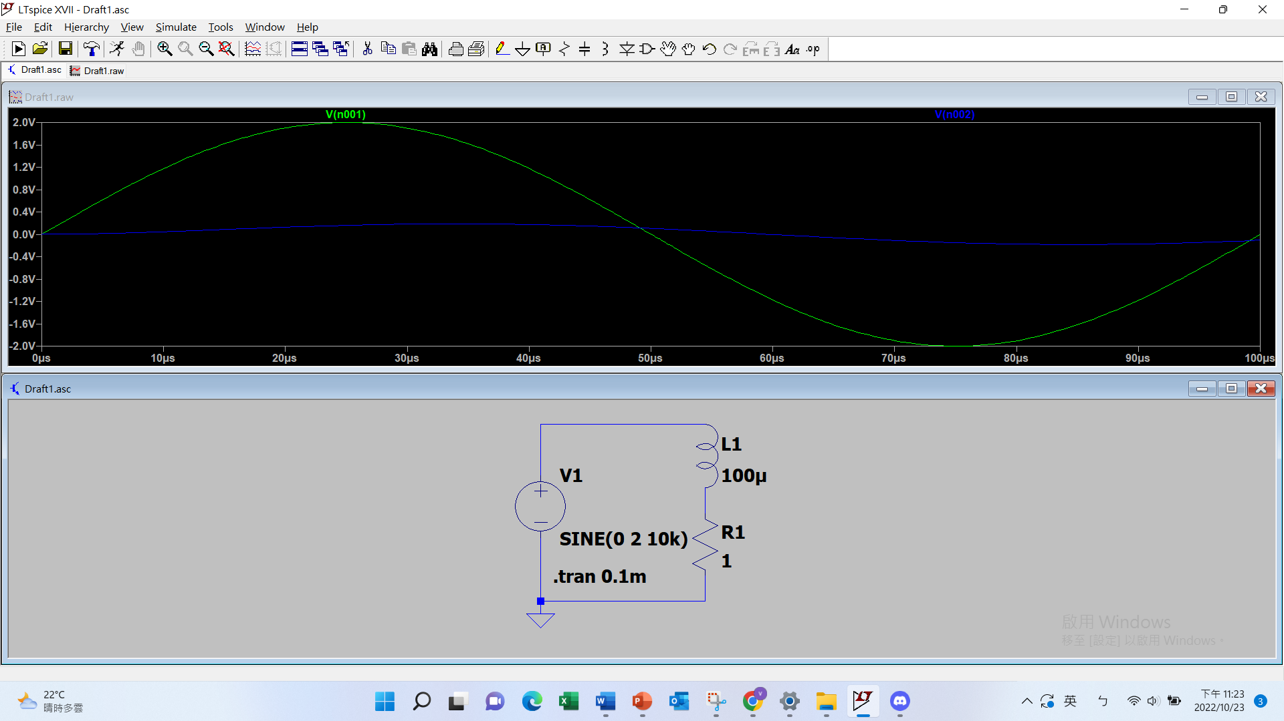

4.

Question:

Please describe the sound produced by different shape.

The sound produced by sine wave is rather smooth, and the sound produced by square wave is piercing. Also, the sound produced by square wave is louder.

(Bonus)Please explain the relationship between discharging RC circuit and time constant. (10pt)

The relationship is given by the following equation:

$$\text{percentage}=1-e^{-\frac{t}{τ}}$$

